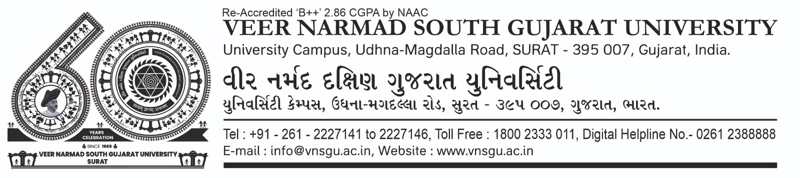

**Department of Information and Communication Technology**

**M.Sc.(Information Technology) Programme**

***Certificate***

This is to certify that Mr./Ms. Dhimar Arin Avinash with exam seat number 120 and SPID 2021013488 has worked on his/her project work entitled as TheCinemaCub at **Department of ICT** as a partial fulfillment of requirement of B.Sc. (Information Technology) - 6th Semester, during the academic year 2023-2024.

Date: 18/6/2024

Place: Department of ICT, VNSGU, Surat

**Internal Project Guide Head of the Department**

**BSc(IT) 6th Semester Department of ICT**

**Department of ICT VNSGU, Surat**

**VNSGU, Surat**